Pharaoh’s Dreams
“God’s timing is perfect” clock craft

God was waiting for just the right time to release Joseph from prison. God could have thrown the prison door wide open whenever He wanted to. But God had a purpose for Joseph in prison. We may never know all that God was doing with Joseph, but we know that God was growing his faith, and God was waiting for the perfect time to release Joseph. The timing was perfect for Joseph, Pharaoh, and everyone in the land. God loves you, and He is ALWAYS at work in your life for His glory and your good (Jeremiah 29:11). Sometimes we can’t see everything God is doing. But you can trust that God’s timing is perfect!
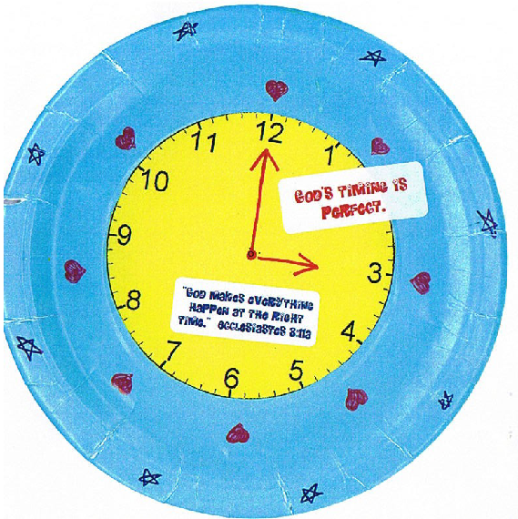

Directions:
- Choose a paper plate
- Copy or draw a clock pattern. Cut out clock and glue to center of paper plate
- Draw in clock hands with marker
- Add Main Point and Key Verse stickers
- Decorate remainder of plate with markers
- Add child’s name on back
Pharaoh’s Dreams
“God’s timing is perfect” clock craft

God was waiting for just the right time to release Joseph from prison. God could have thrown the prison door wide open whenever He wanted to. But God had a purpose for Joseph in prison. We may never know all that God was doing with Joseph, but we know that God was growing his faith, and God was waiting for the perfect time to release Joseph. The timing was perfect for Joseph, Pharaoh, and everyone in the land. God loves you, and He is ALWAYS at work in your life for His glory and your good (Jeremiah 29:11). Sometimes we can’t see everything God is doing. But you can trust that God’s timing is perfect!
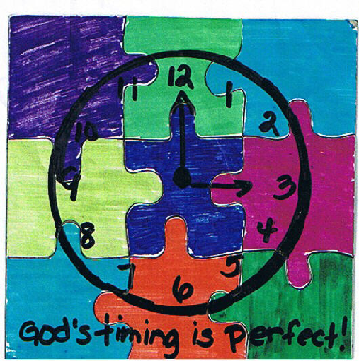

Directions:
- Choose a magnetic puzzle (www.orientaltrading.com, 60/7034)
- Carefully, snap apart puzzle pieces.
- Color puzzle pieces with markers
- Draw a clock on decorated puzzle
- Write today’s Main Point, “God’s timing is perfect” on bottom of puzzle
- Take puzzle apart and put back together!
Pharaoh’s Dreams
“It’s All About Timing”
Watch

God was waiting for just the right time to release Joseph from prison. God could have thrown the prison door wide open whenever He wanted to. But God had a purpose for Joseph in prison. We may never know all that God was doing with Joseph, but we know that God was growing his faith, and God was waiting for the perfect time to release Joseph. The timing was perfect for Joseph, Pharaoh, and everyone in the land. God loves you, and He is ALWAYS at work in your life for His glory and your good (Jeremiah 29:11). Sometimes we can’t see everything God is doing. But you can trust that God’s timing is perfect!

Directions:
- Choose a watch, www.orientaltrading.com, 57/6176
- Place Main Point and Key Verse stickers on back of watch
- Decorate front of watch with markers and stickers

